Heart Rate Variability Testing

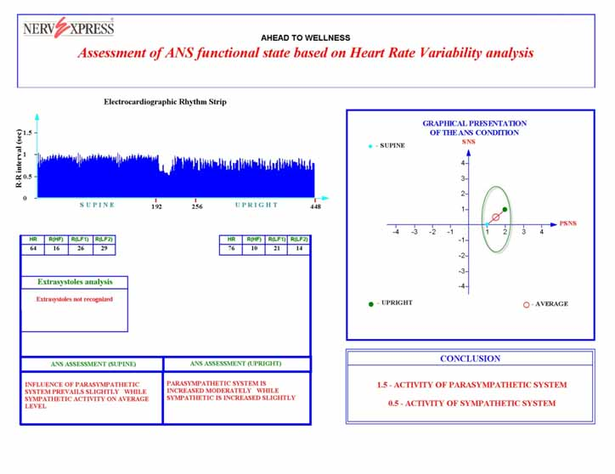
The Heart rate variability test is fully automatic, non-invasive, computer system designed to assess your nervous system using heart rate variations. The test was developed on scientific and medical research conducted in Russia, Germany, France, an the United States over the last 30 years. The system of analysis was designed by Alexander Riftine: Ph.D. Testing conducted at Columbia University Medical Center confirmed the system to be over 95% reliable and accurate in its assessment with industry standards. The heart rate variability test allows precise result for determining the level of physical fitness of your body. This test not only determines your quantity of health but also your quality of health.

The main components that determine “health” are:
- Heredity
- Degree of physical fitness
- Current mental health
- Internal and external stresses

The key advantage of this method is that it accurately detects early development of a disease. This tool will help recognize a potential health problem before your physician would pick it up in a routine examination. Thus,the test becomes an objective tool for early intervention to a disease or illness long before you would complain of symptoms.
The evaluation requires measurement of your heartbeat lying down and standing up. The computer than analyzes the similarities and the differences between the two. It then gives you both a graphic indicator as well as numerical value of how health you are (or are not).
This system far surpasses any other diagnostic tool we currently have. The reason being is that it is the first diagnostic tool that compares you to other healthy people as opposed to other sick people. Your results are compared to the world’s top athletes. There is no other diagnostic database that has this advantage.
It can also be used to monitor any treatment plan and can be used under any medical doctor’s care to monitor your improvement on a medication, under a cardiologist’s care to monitor the improvement of your cardiovascular system, under your chiropractor’s/nutritionist’s/massage therapist’s care to establish that their treatment is encouraging improvement in the nervous system.

